**Total Triage System**

Sancta Maria Centre will be making a significant change to our appointment system that will improve the way our surgeries deliver care to all our patients.  From the 3rd April 2025 we will adapt to the Total Triage system, this is a new approach recommended by NHS England to improve patient accessibility and quality of care within Primary Care Services.

**What is Total Triage?**

Total Triage uses an online consultation system in which patients submit their symptoms or request to their GP electronically.  A clinician will review all medical requests and assign to the most appropriate resource based on the information provided by the patient, this could be a GP, Advanced Nurse Practitioner, Pharmacist, Physiotherapist etc and assess how best to manage the request i.e. a face-to-face appointment or a telephone consultation.  Practices are then able to manage demand via a single workflow, prioritising care based on need, rather than a on a first come, first served basis.  This approach helps ensure equity of access for digital and non-digital users.  It can also free up the phone lines for those who cannot go online.

**Submitting your request**

The quickest way to get in touch with us is to select the eConsult link on our website.  If you are a non-digital user or find it difficult to use online access you can call the surgery or visit the surgery during our open hours and a member of the administrative will fill out the form on your behalf.

Non-digital users may be supported by carers or are taken through the same online form or a short template by administrative staff over the telephone or in person (with some agreed exceptions, prioritising care based on need, for example, vulnerable patients).

**After your form is submitted**

All medical requests are reviewed by a clinician who will assign the request to the most appropriate resource based on the information provided by the patient. You may be offered a consultation via telephone or face to face or you may be sent a text message or email that requires an action or further information, whatever way we get back in touch with you, you can rest assure that we are always looking after your needs.

We understand that change can be difficult, but we are confident that this new way of working will benefit you.

**What is the benefit to you?**

* Improving access to care: by prioritising patients, waiting times for those with urgent medical needs is reduced. Patients receive timely care, leading to better outcomes. Triage ensures that limited healthcare resources are allocated to patients who need them urgently.
* Improving patient safety: triaging helps to identify high risk patients early, allowing healthcare providers to intervene promptly, preventing complications and reducing the risk of adverse events.
* Convenience: Requests can be submitted throughout the day, reducing the current 8am telephone rush and eliminating unnecessary travel and potential travel costs.  You can access wherever you want from any device, unlike a telephone call you complete a total triage form at a pace that suits you.
* Better patient experience: Improves communication and ensures that everyone receives the care most suited for them.

**What if you have trouble using the new system?**

If you have any accessibility needs, no on-line access at home or you are unable to use digital services, you will be able to call reception or visit the surgery, but please note that we will no longer be able to book you an appointment directly, staff will assist you by completing the online form on your behalf.

**This is the recommended model for practices to move to, enabling requests to enter through a single workflow and matching the approach for providing care to the person, the circumstance and their needs.**

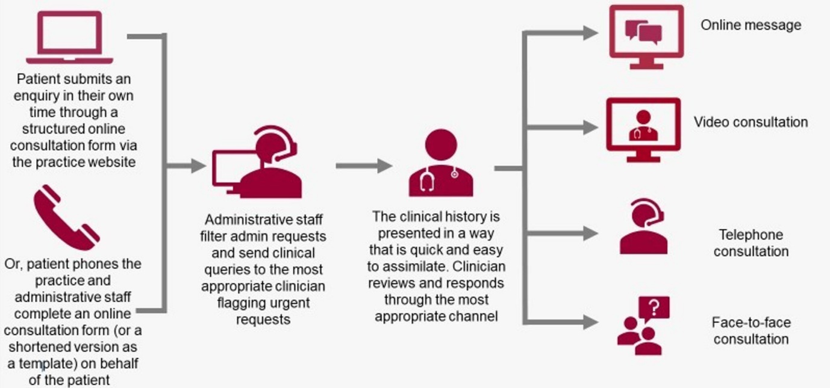

If you have any questions or concerns please do not hesitate to contact us, our team is here to guide and support you.

Thank you for supporting us with this new project to improve patient access and care.